Design a database for YB college:
- Project scope (short paragraph)
Write a story that defines the purpose and scope of the database. Describe the main entities (e.g., students, lecturers, etc).
A database that tracks course enrollments and allows access for students, lecturers, and admins. This database will track the number of enrollees per course. It will allow students and lecturers to access relevant data. Lastly, this database will enable admin users to manage course data. Here's a breakdown of the entities, their attributes, and the relationships between them:
- Student
- Lecturer
- Admin
- Course
- Enrollment
- Fees
- Subjects

🔗 Relationships
- Student ↔ Enrollment ↔ Course
A student can enroll in multiple courses; each course can have many students.
- Lecturer ↔ Course
A lecturer teaches one or more courses.
- Course ↔ Subject
A course can have multiple subjects.
- Student ↔ Fees
Each student has associated fee records.
- Admin ↔ Student / Lecturer / Course
Admin can add, update, or delete records for students, lecturers, and courses.

- Entities and EER diagram
List all entities with brief descriptions of their roles and attributes (e.g., Student, Course, 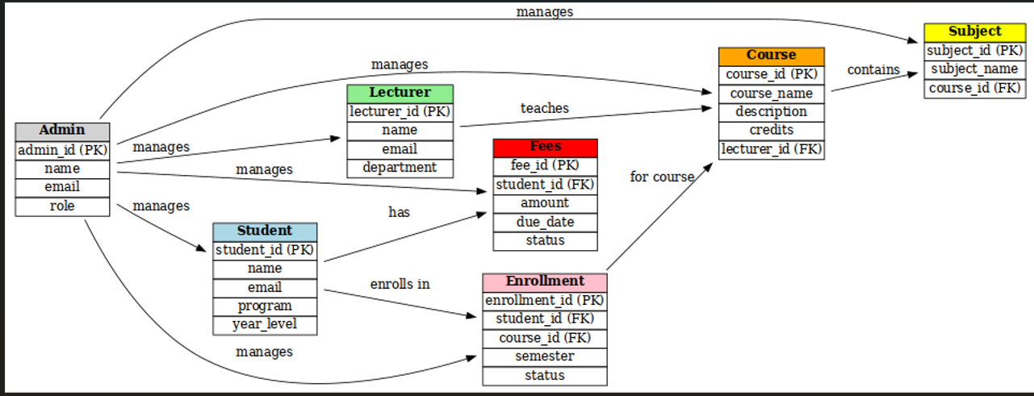

- Table design
State how many tables are required after mapping the EER to a relational schema.

- Student
student_id (Primary Key)
name
email
program
year_level

- Lecturer
lecturer_id (Primary Key)
name
email
department

- Admin
admin_id (Primary Key)
name
email
role

- Course
course_id (Primary Key)
course_name
description
credits
lecturer_id (Foreign Key)
- Subject
subject_id (Primary Key)
subject_name
course_id (Foreign Key)

- Enrollment
enrollment_id (Primary Key)
student_id (Foreign Key)
course_id (Foreign Key)
semester
status (e.g., enrolled, dropped, completed)

- Fees
fee_id (Primary Key)
student_id (Foreign Key)
amount
due_date
status (paid/unpaid)

